

**Error Correction Report**

**Group Members:**

1. Zainab Asim
2. Minahil Noman
3. Ahmad Jalil
4. Ali Hamza

**Error # 1:**

In the categories section of the admin panel, there was an error when you tried to delete the Category nothing happened in the result.

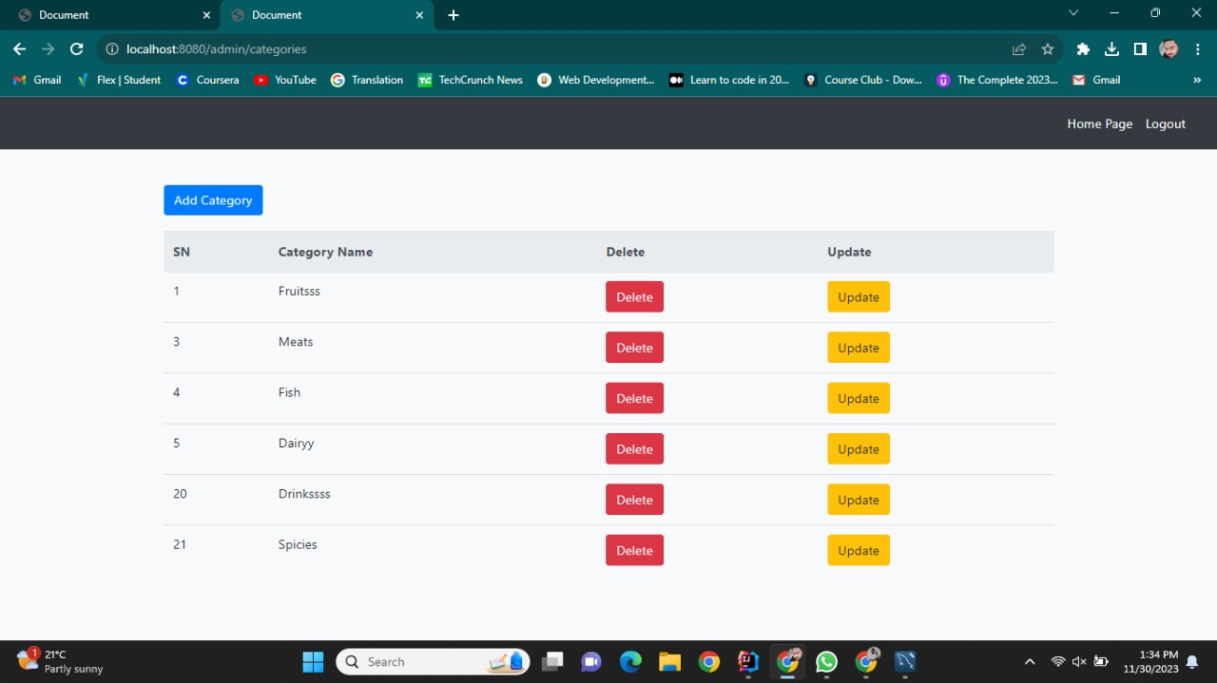

**Solution:**

We have solved this error and added the deletion functionality in the categories section.

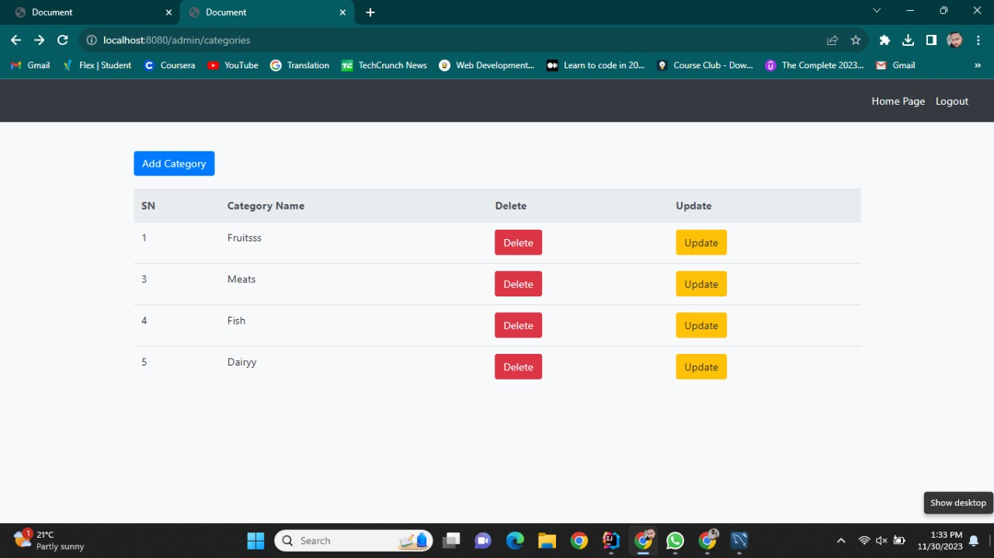

**Error # 2:**

When the user and admin tried to log out the logout functionality wasn’t work accurately.

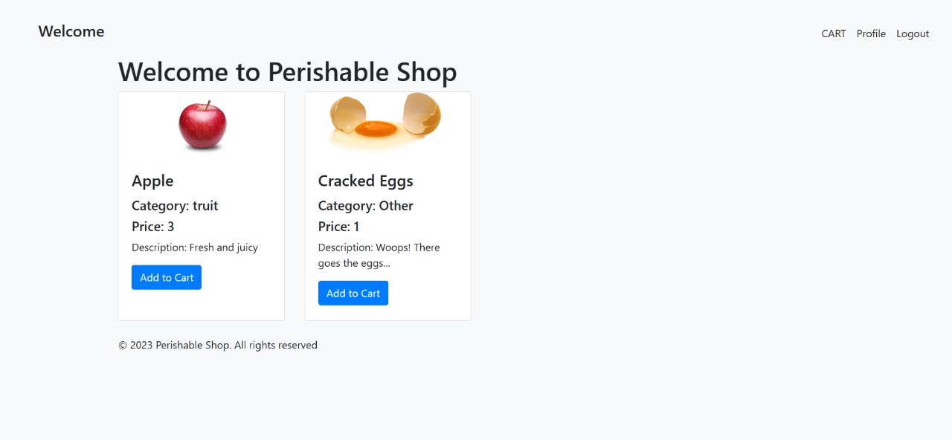

**Solution:**

We have solved this error and added the logout functionality in both the user and admin panel

.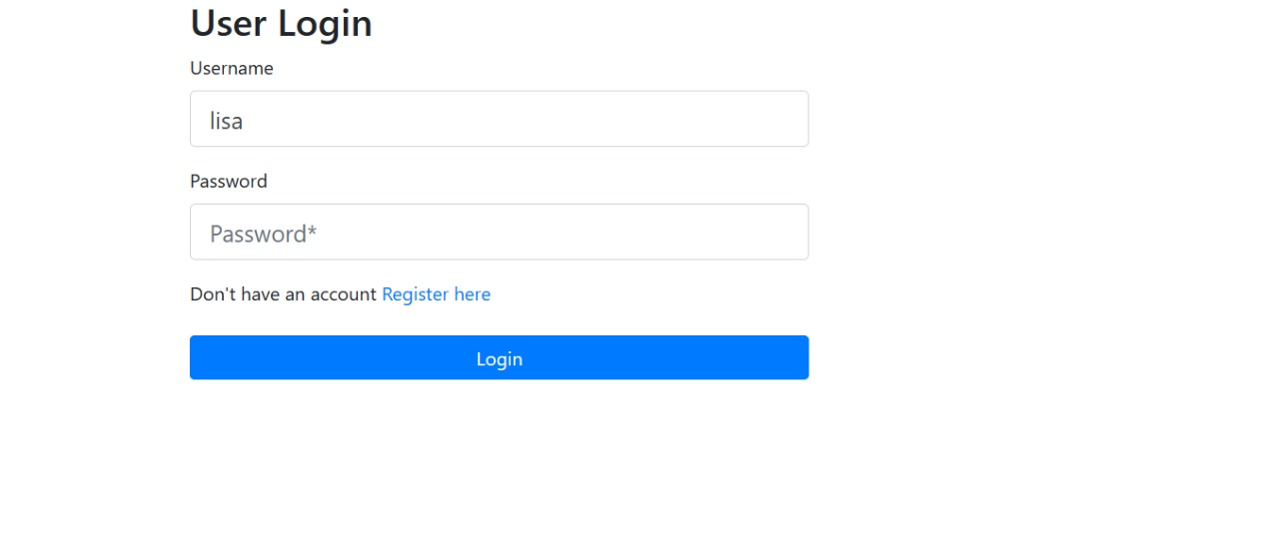

**Other Error:**

There was also an error in the delete customer option we have fixed that error.